**INTRODUCTION:**

This dashboard is based upon the public data having 80 explanatory variable with one regressor with 000’s rows.

The following is the pictorial presentation of the dashboard ( APNA GHAR) using shiny application, presents all outcomes of house price prediction, contains FOUR fluid sheets namely plot, Predicted_value, Fitted model, and prediction.

**DASHBOARD SUPREMACY USED:**

1. All-in-one:

APNA GHAR dashboard allows us to look, at a glance, an overall situation report of the desired information.

2. Customizable:

Dashboards could be customized in terms of users and expectations. Each decision level dashboard can be customized to present the most valuable and useful set of information. This allows each person to see the level of detail that they need in order to get their job done and meet their goals.

3. Drill into details:

 But, having all-in-one does not means the absence of details. Dashboards are developed with the ability to get as deeper in information as required by simply selecting the desired variable or object.

**FLUID PAGE 1: PLOT**

The following page contains three graphs, Ist , the graph between Sale-price and garage cars shows, years in which the house price is effecting by garage cars.

Second graph, gives the answer of, number of houses contain a particular no. of sale-price.

Third one can be changed through slider (given in the left), gives a relationship between sale-price and year built.

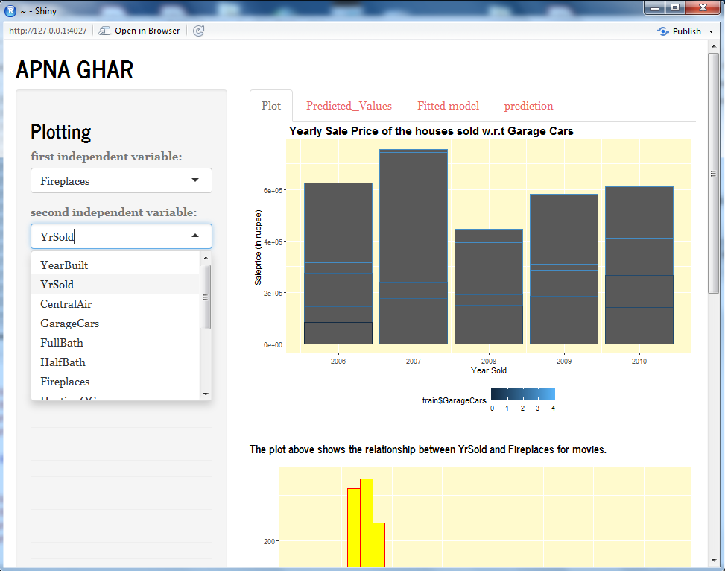

PAGE CONTINUED

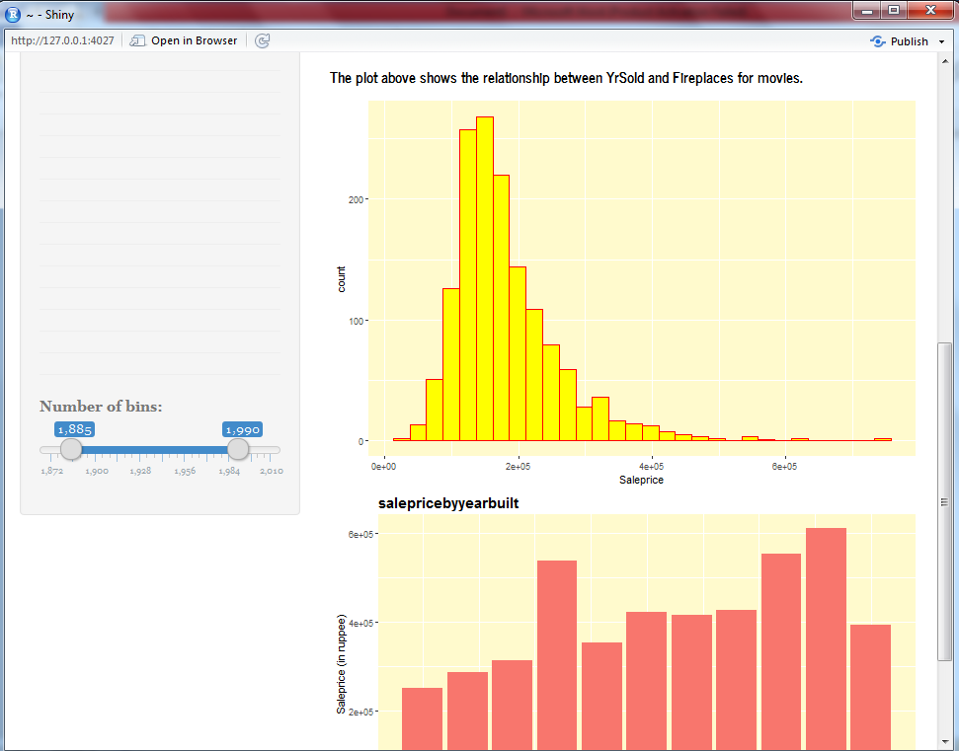

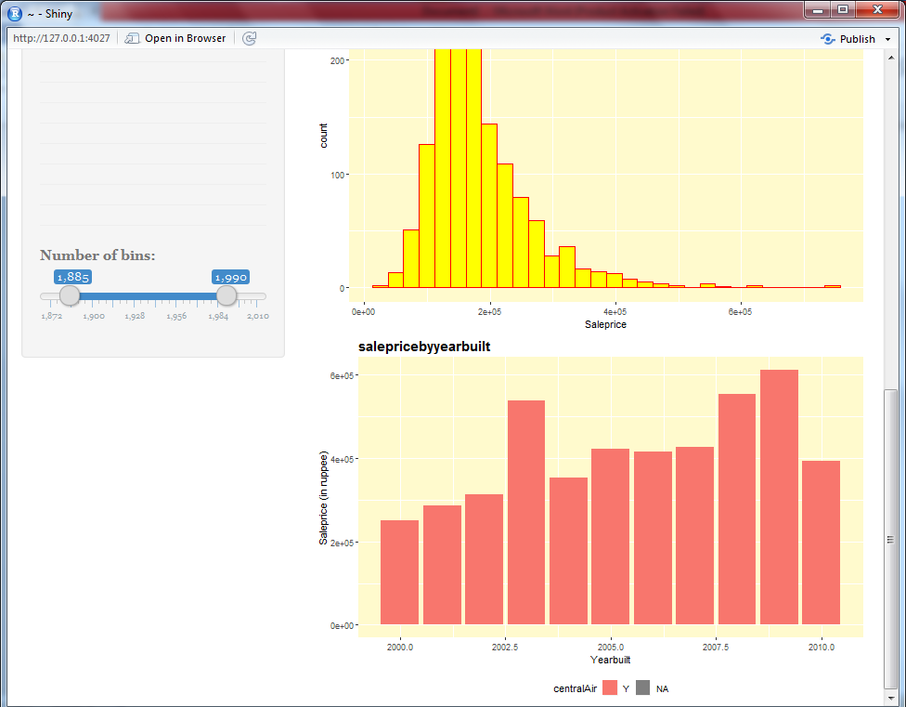

**FLUID PAGE 2: Predicted_value**

Gives a glance of, how data looks like, we can change entries, if desire to look upon further data, as shown next.

Below is the graph of predicted value which is positively skewed and can be compared with train data sale-price graph (in fluid page 1, also positively skewed). Hence, our prediction is in right direction.

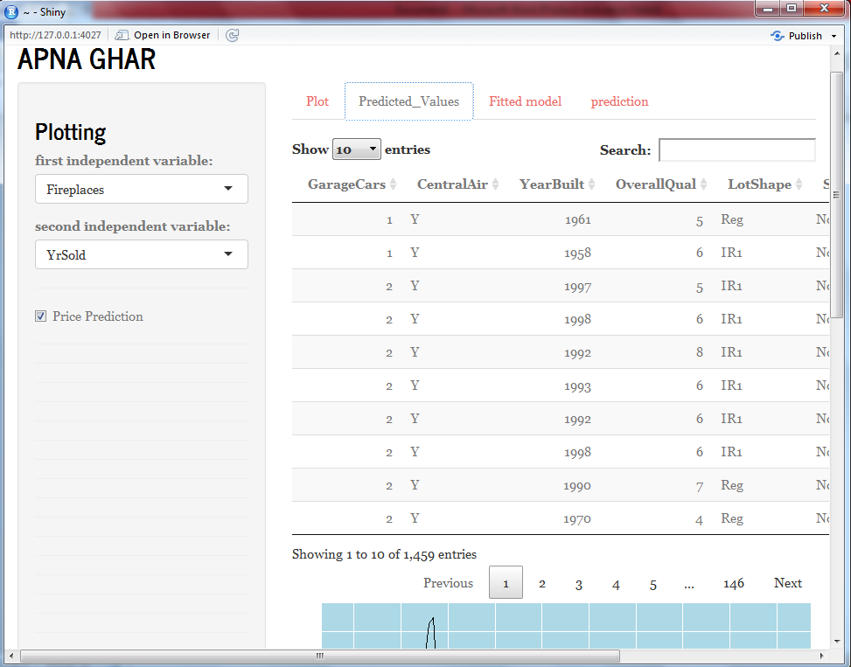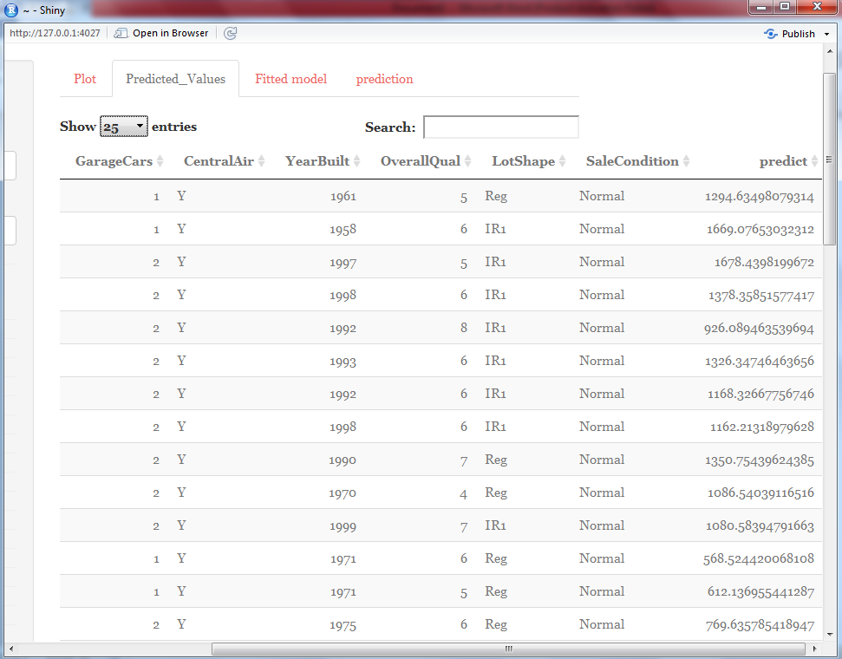

PAGE CONTINUED

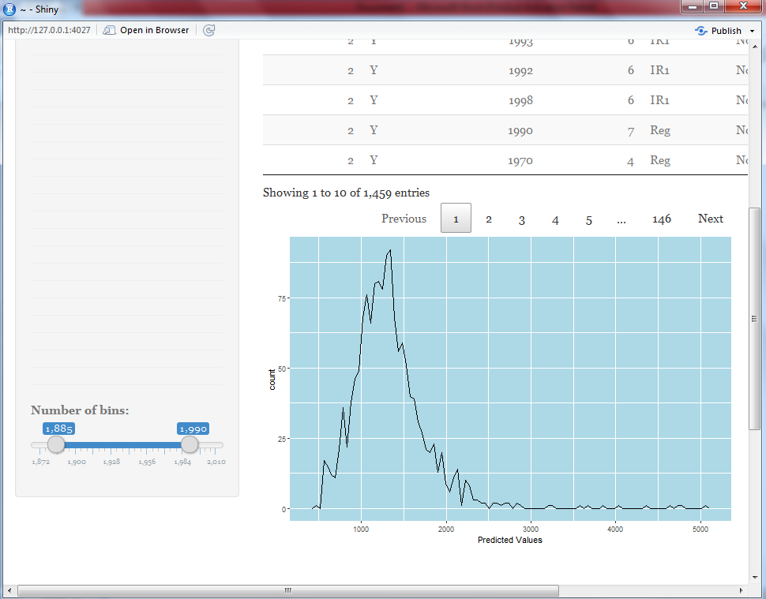

**FLUID PAGE 3: Fitted value**

This possesses two model prediction summaries using linear regression model.

First, is user defined, one can select their own explanatory variable as per their requirement and summary of the same will mechanically be created.

Whereas, Second is the model summary by taking all necessary variable into consideration ( using different tools).

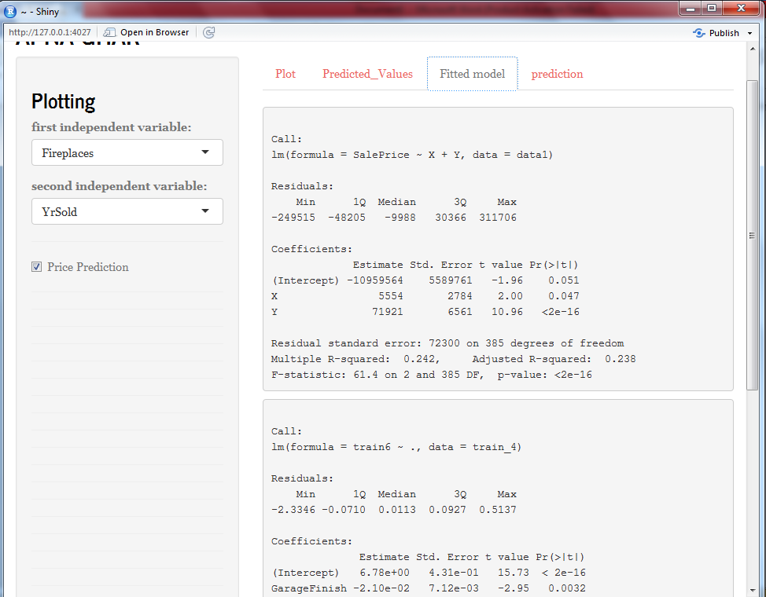

PAGE CONTINUED:

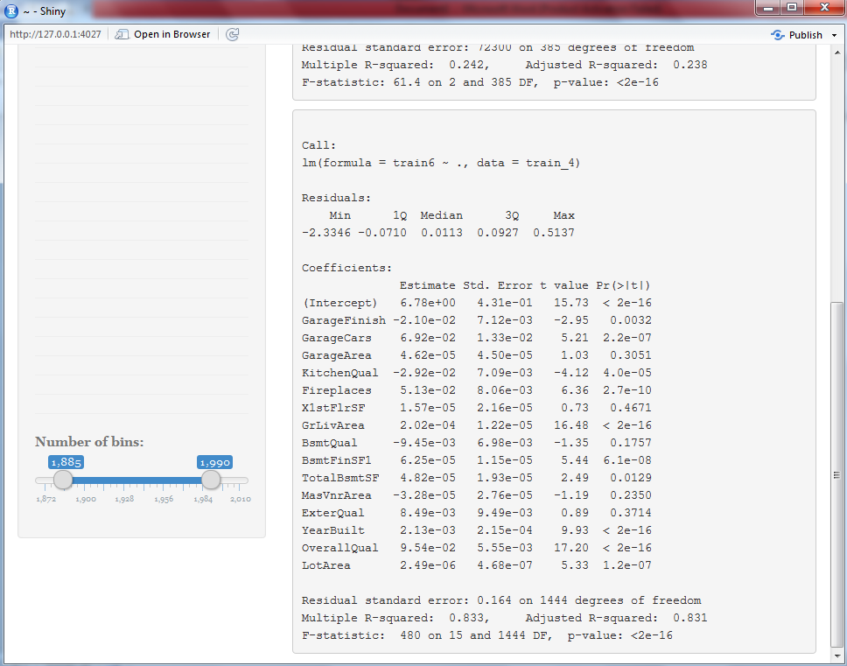

**FLUID PAGE 4: Prediction**

A user friendly page contains few of necessary variables which is high in demand while purchasing house, user need to enter their specification as per their requirement and price of their dream house can be generated by machine.

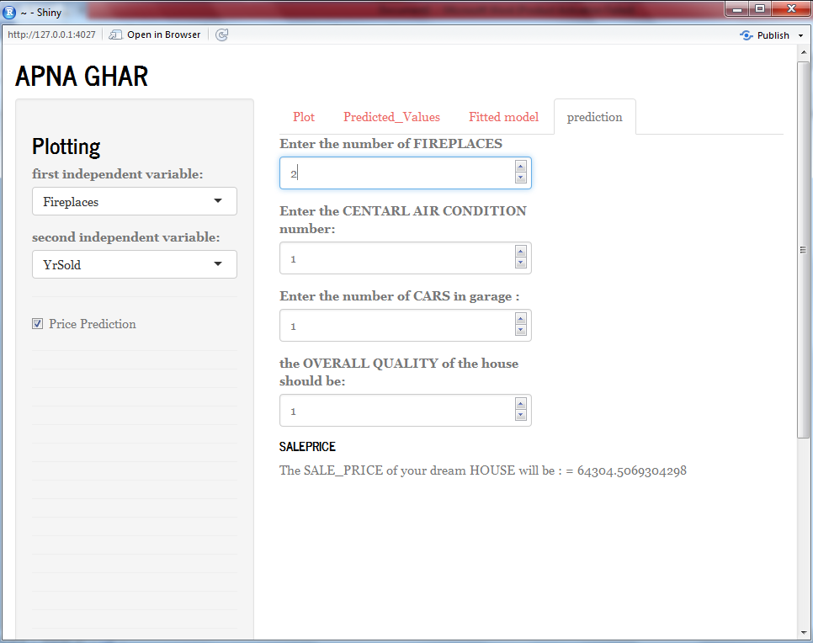

PAGE CONTINUED:

